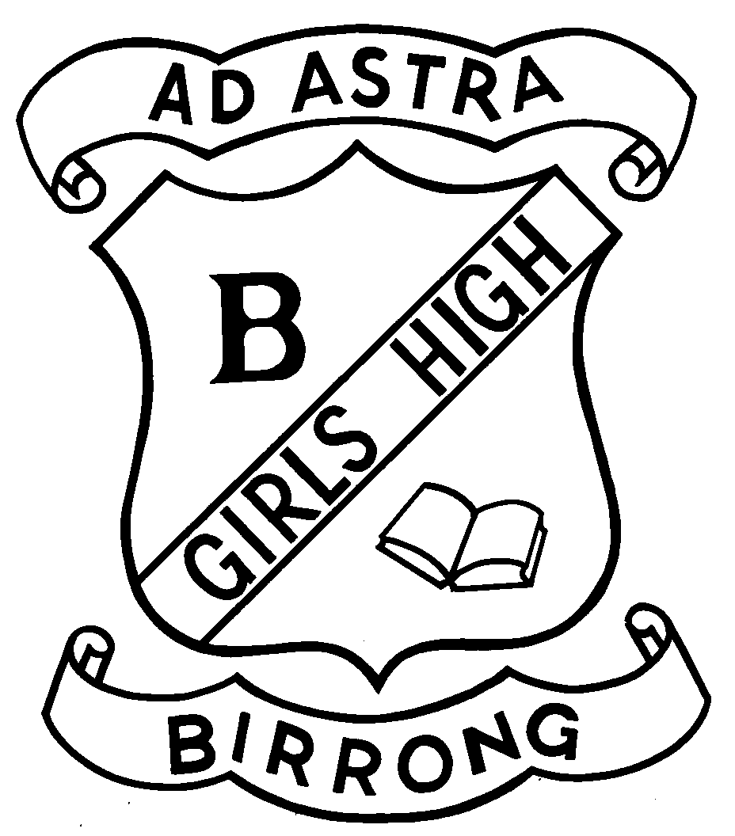
BIRRONG GIRLS HIGH SCHOOL
Principal: Z Dabaja Telephone: (02) 9644 5057 Fax: (02) 9644 8157 Cooper Road
BA Hons (Eng Lit) (USYD), DipEd (USYD) BIRRONG 2143

1 August 2022

Dear Parents and Carers,

Our school has been advised that members of our school have recently tested positive to COVID-19.

Students and staff within our community may have had contact with a person who was infectious with COVID-19. While testing and isolation is no longer mandatory for exposures in school settings, NSW Health has provided advice for the community following exposure to COVID-19 that should be considered when making decisions for your child and family. Please see the following link.

https://www.nsw.gov.au/covid-19/management/people-exposed-to-covid

You are reminded that staff and students cannot attend school if they are showing any symptoms of COVID-19. These include fever, cough, sore throat, shortness of breath, runny nose, loss of smell/taste, muscle/joint pains, diarrhoea, nausea/vomiting, extreme tiredness, unexplained chest pain or conjunctivitis (eye infection). If symptoms occur at any time, you should not attend school and should undertake a rapid antigen test. If a rapid antigen test is positive you/your child should isolate as someone who has tested positive to COVID. If you cannot access a rapid antigen test, you can attend a PCR (nose and throat swab) testing clinic.

In keeping with the latest COVID safe practices students who are close contacts must notify the school prior to attending, wear a mask at all times and test every day for 5 school days prior to coming to school.
RAT kits are available for families who need them

Advice and further resources are available on the NSW Health website including COVID19 guidelines and fact sheets for people who tested positive or were exposed to COVID19. The safety and wellbeing of our staff and students is paramount at all times. As such, we will continue to ensure that all necessary health advice is closely followed.

If you have any additional queries or concerns, please contact the school on 9644 5057 and schedule an appointment for a phone or zoom communication with the Principal, relevant Deputy Principal or Year Adviser.

Thank you for your ongoing support.

Zena Dabaja
Principal

