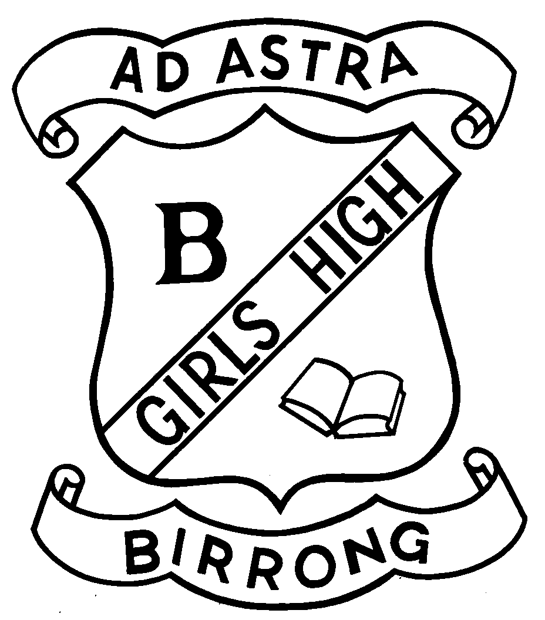
BIRRONG GIRLS HIGH SCHOOL
Principal: Zena Dabaja Telephone: (02) 9644 5057 Fax: (02) 9644 8157 Cooper Road
BA (Hons) DipEd BIRRONG 2143

Dear Birrong Girls High School community,

I write to you with details regarding the return to full time face-to-face learning that will commence as of Monday, 25 May 2020. We are thrilled at the prospect that our school community will be reunited and ready to engage in the productive learning partnerships that prepare your child for their post-school future. Below, you will find the necessary information about the full time return that we are looking forward to.

A guide to NSW school students returning to face-to-face learning

This guide is for parents and carers. Information has been updated as at 19 May 2020, until further notice.

Schools are safe and open for full time face-to-face learning

All schools are returning to full on-campus learning from Monday, 25 May. This is Week A on the school timetable. All school activities and operations will be in line with Australian Health Protection Principal Committee (AHPPC) and NSW Health guidelines as applicable. School students do not need to follow physical distancing guidelines, but should follow good hygiene practices like:

• Regularly washing hands
• Use the sanitation stations around the school
• Avoiding sharing drinks or food
• Coughing or sneezing into your elbow, or a tissue which should be discarded immediately
• Avoid physical contact.

School attendance

All students should be at school, unless:

• They have a medical certificate which states that they are unable to return to school due to an ongoing medical condition.

• They are currently unwell. Students who have a medical certificate to stay at home will be supported to learn from home in line with regular procedures if they are able to. These regular procedures are different to what was offered during the learning from home period. If you require work to be provided to your child whilst they are at home due to an underlying health condition, you should contact the school for assistance. Please note, students who live with a family member in one of the categories identified as being at increased risk by the AHPPC, should attend school unless a medical practitioner advises otherwise in writing. If your child is unwell, do not send them to school. If they are unwell at school you or your nominated emergency contact will need to collect them immediately. Please make sure your contact details are up to date. If a student is absent without a medical reason for more than three days, this will

be recorded as an unauthorised absence and followed up by the school. If you need any support to get your child back to school, please contact our office staff.

Reporting and assessment

Your child has been assessed during the learning from home period and will receive additional assessment on their return to school. You will receive your child’s Semester 1 report before the end of Term 2.

School activities

Teachers will continue to follow the same school curriculum with the exception of some activities that cannot proceed for the time being.

What can go ahead:

• Use of the school library
• Engagement in non-contact sporting activities
• Attendance of HSC classes scheduled on other campuses (this does not apply to BGHS)
• VET work placement for Year 12 students is able to proceed from 1 June 2020. Year 11 work-placement is able to proceed from Term 3 2020.
• School based apprenticeships and traineeships can recommence once the relevant workplaces are back in operation

What cannot go ahead:

• School assemblies (unless for critical information)
• School incursions and excursions including camps
• Work experience
• Inter-school activities (debating, inter-school sport)
• In-school activities requiring parent or other volunteers
• Drinking from a water bubbler – bring a water bottle instead
• Attending TAFE for additional study (students may continue to learn online)

School cleaning and hygiene supplies

Birrong Girls High School is receiving additional cleaning in line with the AHPPC guidelines and advice from NSW Health. Targeted areas include high-touch areas and other hard surfaces, door handles, lockers, light switches and handrails in stairways and movement areas. There will also be additional cleaning of toilets and bubblers and topping up of supplies like soap.

Students have been sanitising their work stations as they move from class to class for additional safety. This is good hygiene practice. Lessons that involve practical tasks will also follow specific protocols to sanitise spaces and equipment. Students may be involved in this process during lessons.

We also have additional supplies of soap, hand sanitiser, toilet paper, paper towels, disinfectant wipes and personal protective equipment. The school is able to order more as needed.

School grounds

There should be no visitors to school sites unless they are essential. Parents are encouraged to call the school when they have a query or concern.

Drop off and pick up procedures

Public transport continues to run as usual for students who require it.

Parents are advised to follow road rules and safety procedures when driving, dropping off and picking up within the school zones. This includes adhering to the speed limit and rules about parking, stopping, signalling and departing.

There have been some minor adjustments to student entry onto the school grounds.
Students can no longer enter or exit through the office foyer. There is a student pathway near the school hall that is now the formal entry onto school grounds. Students who access the school through Cooper Road must enter through the school gates and then walk along the pathway adjacent to the school hall to alight onto the student pathway. This will lead them through the side gate north of the school where there is a sanitisation station. Students who descend from Birrong Station or are dropped off at the southern (back) gate may enter and use the sanitisation station set up in that location.

P&C and other community meetings

P&C meetings will be conducted virtually until otherwise advised. Notification about the meeting will be provided and parents can register their intention to attend. Details of the virtual meeting will be issued following registration.

Parents are invited to schedule phone interviews with teachers to discuss student progress when required and, in particular, upon receiving reports.

Parent Teacher Interviews will not be conducted in the same manner. Alternate arrangement will be advised in the coming weeks.

School Canteen

The school canteen will be operational from 25 May.

Uniform shop

The uniform shop is open. Social distancing and hygiene protocols apply and must be respected at all times. Prior orders have arrived and are awaiting pick up. Timeframes for new stock are subject to production, shipping and quarantine guidelines.

Responding to COVID-19 cases

To date, there have been no cases of COVID-19 connected to our school community. There is a clear plan in place for schools to respond to any suspected or confirmed cases of COVID-19 in our schools. We are working closely with NSW Health and will communicate with parents any necessary information.

We continue to encourage our community to minimise social interaction and adhere to social distancing and hygiene protocols with the aim to contribute to eradicating the threat this virus has posed to our nation.

We look forward to welcoming back our whole community and feel confident that we will continue to work together to ensure the safety and productivity of all our community members.

Additional enquiries can be made by calling the school on 9644 5057.

Yours sincerely

Zena Dabaja

Zena Dabaja
Principal
20/05/20

