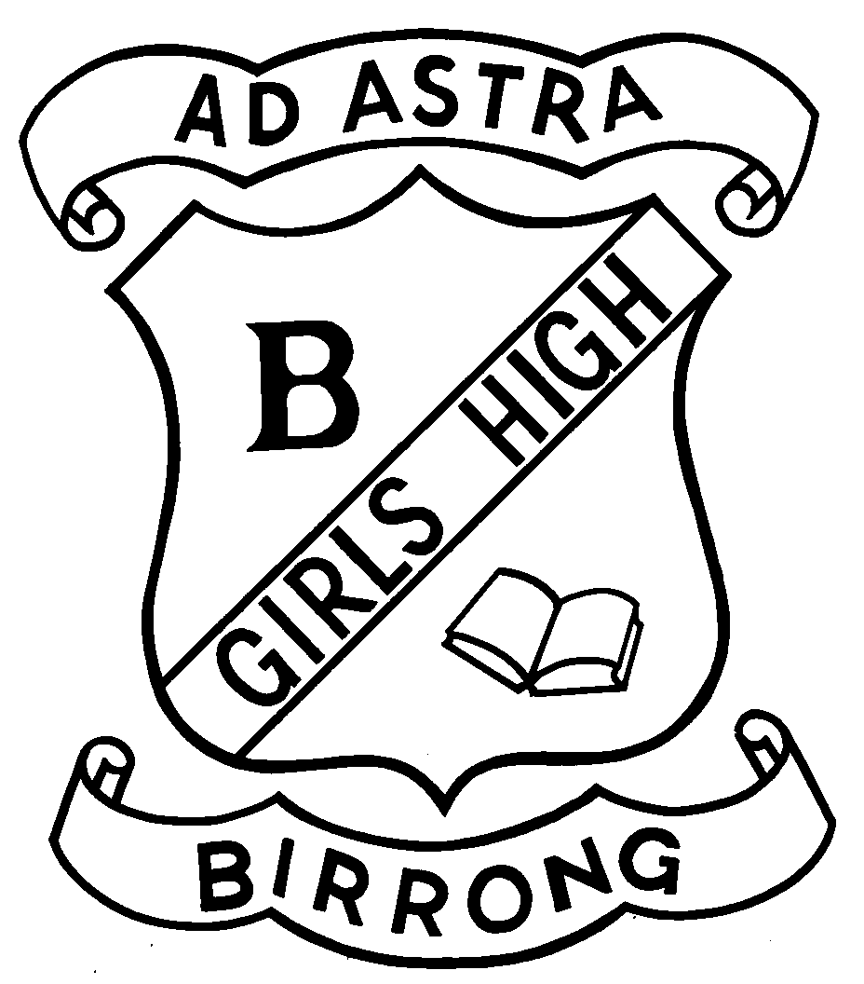
BIRRONG GIRLS HIGH SCHOOL
Principal: Zena Dabaja Telephone: (02) 9644 5057 Fax: (02) 9644 8157 Cooper Road
BA (Hons) DipEd BIRRONG 2143

School Uniform Price List

Item Description | Sizes | Price $
Girls Summer Dress | 2 to 26 | $72.00
Girls Mid Length Skirt (Senior) | 2 To 26 | $47.00
Girls Full Length Skirt (Junior) | 2 to 26 | $54.00
Girls Full Length Skirt (Senior) | 2 to 26 | $ 54.00
Girls Short Sleeve Blouse | 2 to 26 | $29.00
Girls Long Sleeve Blouse | 2 to 26 | $30.00
School Pants | 2 to 26 | $32.00
Knit V Neck Jumper | 2 to 26 | $ 52.00
Blazer | 2 to 26 | $ 154.00
Sport Uniform
Sport Polo- Short Sleeve | 2 to 26 | $29.00
Sport Polo -Long Sleeve | 2 To 26 | $ 30.00
Sport Short | 2 to 26 | $22.00
Sport Pants | 2 to 26 | $43.00
Sport Jacket | 2 to 26 | $51.00
Sports Cap |  | $20.00
Accessories
Scarf | One size | $15.00
Stocking (2 Pairs) | Mid/Tall/Extra Tall | $16.00
Socks (Crew) |  | TBA
Calculator |  | $25.00
Highlighters | 1 Pack | $4.00
Hand Sanitiser |  | $5.00

